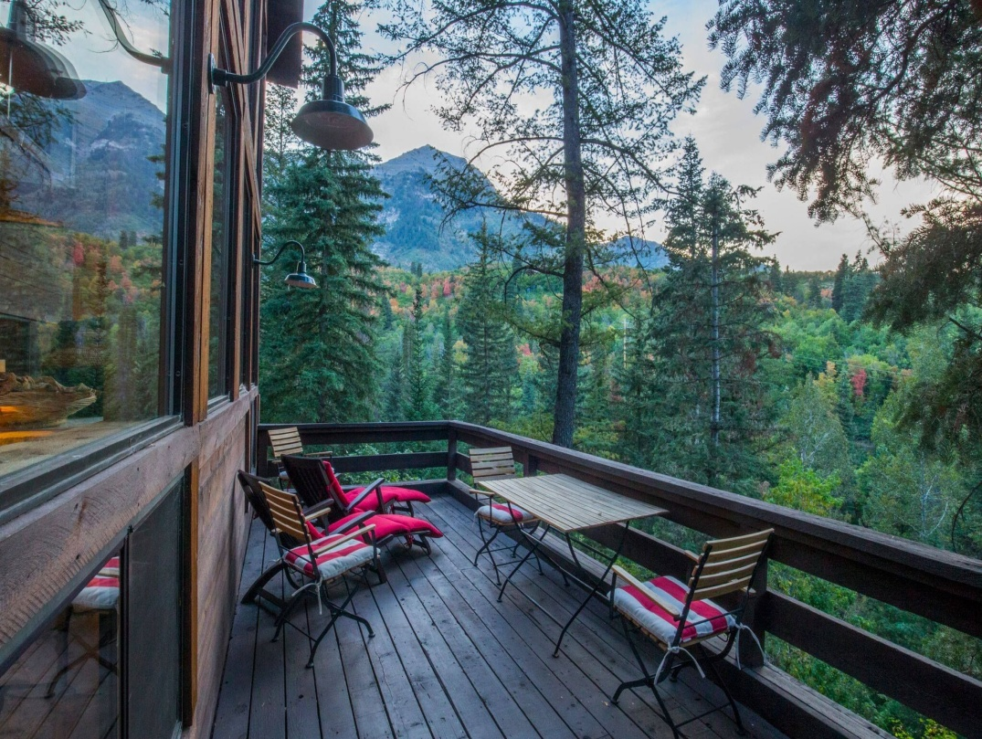

Rocky Mountain Holistic Skin Care and Wellness Spa

421 N Downing St, Denver, Colorado 80218
1 (720)- 844 - 9701
Alicia James and Jaicah Hamrick

Title Page 1
Table of Contents 2
Executive summary 3-4
Vision 5
Company Overview 6
Product Service 7
Market Analysis 8
Marketing Plan 9
Financial Plan 10-11
Supporting Documents 12

Executive Summary
Rocky Mountain Holistic Skin Care and Wellness Spa was founded in 2010 and has been a partnership since 2012. We are located in the capital of Colorado in Denver. We base all our treatments and products on natural, traditional ideas and methods. Our mission as a spa is to create a relaxed, welcoming environment in which we can ease our clients mind, body, and soul while using natural and holistic methods to heal and treat various clients needs or superficial conditions from the inside out! Making our clients look and feel beautiful.We got started in 2010 by our founder Alicia James. We started out as a simple spa and eventually grew into the diverse Wellness Spa we have today! Jaicah Hamrick an Alicia James are our key management personnel at Rocky Mountain Skin care and wellness spa. We took a lot into consideration when choosing product lines to use and retail in our spa, only the purest and most high quality ingredients are used in our products, which all cruelty free, NON-GMO, non-toxic, and Certified Organic! We offer a wide range of services varying from facials to reflexology, body polishes, vichy showers, hydrotherapy, mineral springs, waxing, and customized service plans based on individual client needs! We sell our products online, in-house, and we offer samples to gives clients a chance to be reassured in a new product before investing. We also have a business page we use to offer sales and special deals for holidays, special events, senior citizens, etc. our Major competitors are the Koa House, Salt Caves Wellness Center, Superb Spa, and a few other specialty spa centers in the Denver Area. We offer the most diverse range of services of any spa in our area, and the products we use are a unique perk to compliment our unique service. We will initially need no extra funding as Ms. James won the $2m lottery which drove her to begin her dream of opening her skin care center. We will finance our spa through Ms. James lottery fund.

Vision
Our mission as a spa is to create a relaxed, welcoming environment in which we can ease our clients mind, body, and soul while using natural and holistic methods to heal and treat various clients needs or superficial conditions from the inside out! Making our clients look and feel beautiful.

Goals are to create long-lasting clients, be a top spa in our area, and be a green spa.

Our objectives include making a positive impact on the community, having an on-site RN, establishing our name in the trending world.

We will achieve our goals by making connections with local shops, getting involved with local fundraising and charity, and making a professional and well-known name for the spa.

In the future we hope to have created a brand for our business and have expanded across at least to fives more locations in bordering states.

Company Overview The location was purchased In 2010 and became a partnership with Jaicah Hamrick in 2012.
Ms. James is a financial business major and deals with all financial, legal, management, and practical business aspects, whereas Mrs. Hamrick organizes the type of treatments, tools, and products used in the spa while keeping up with the latest trends in the beauty world and good investments for the spa.
We pay a beginning hourly wage based on experience and knowledge; we also offer classes to continue education and training. All of our employees are hired through careful consideration and selection, and thus we provide a space for them to practice in without a rental charge or fee. Personnel we intend to hire in our spa include seasoned estheticians, massage therapists, reflexologist, RN, lash technicians, and a holistic care specialist. Management, Lawn and landscape crew
Product Service
The product lines we use are Apothocare, Farmacy, Dr. Alkaitis, and juice beauty. All of which are organic and cruelty free, and GMO free!

The services we offer in our spa range from facials to reflexology, body polishes, vichy showers, hydrotherapy, mineral springs, waxing, and customized service plans based on individual client needs!

In the future we hope to add new services and techniques as the beauty world grows and changes! We will always put customer satisfaction first.

Market Analysis
We are located in Denver, Colorado, one of the most rapidly growing and changing cities in the U.S. We have an extremely diverse population in our city.
We hope to attract clients that care not only about their looks, but their health as well.

We have many spas in our city who also offer unique services, such as the Koa House, Salt Caves Wellness Center, and many more that are dedicated to their work!

Parking in definitely our biggest task to face, since Denver is such a rapidly growing and populated city, it’s often difficult to find parking. Luckily, our spa is located on a quieter street in Denver so we have much more availability to parking but we plan to extend our driveway in the future!
Market Plan

Our sales strategy is having products available to buy in- store and online through our website! We also have various deals for certain days, ages, college students, and more!
We will advertise over the internet, word of mouth, Tv/Radio ads, on social media and any other way we can.
We will promote our business by targeting locals through various forms of advertisement.
We have a social media coordinator and we plan to attend local festivals and get involved with our community.We currently have a team of local marketing majors creating our ads.
Financial Plan
Our initial costs will total up to $60,784.
Within the first 3 years we expect exceed half a million in client services alone, retail is expected to exceed $119,000
Operating budget for one year is expected to be $88,000
Estimated expenditures for the next 3 years are $284,000
Current Assets |  | Current liabilities
Cash $97,000 |  | Account Payables $320
Accounts receivable $60,500 |  | Short-term Payables $200
Inventory $30,003 |  | Others $1,115
TOTAL Assets $187,503 | Total Liabilities $1,635
FIXED Assets | LONG-TERM Debt
Equipment $6,000 | Bank Loans $10,004
Land $88,000 | Notes Payable $450
Building $30,070 | Other Loans $150
TOTAL FIXED ASSETS $124,070 | TOTAL LONG-TERM DEBT $10,604
TOTAL ASSETS $ 311,573 | TOTAL LIABILITIES $12,239

We will use the funds to build up our business
We will use a separate property as collateral
We will pay loans back monthly
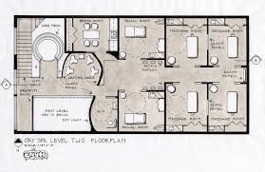
Lash Artist: Performing lash work in main room area
Estheticians: work in spa area
Massage therapists: Work in massage rooms
Reflexologist: In reflexology room
R.N. : Across the floor
Holistic Care Specialist: in care room

